INTEGRATIVE COURSE IN PSYCHOLOGY (ICOPSYCH)

ANALYSIS ON THE RESULT OF PRE-BOARD EXAMINATION IN ABNORMAL PSYCHOLOGY
MARCH 8, 2025
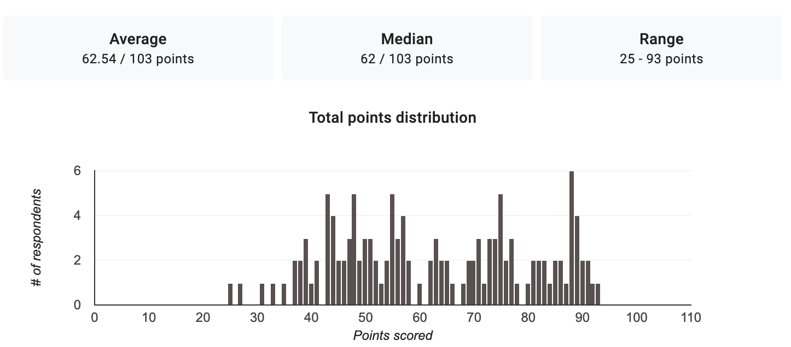

1. Mean Score: The mean (average) score of the exam is 62.54 out of 100. This suggests that, on average, students scored a little over 62.5, indicating a moderate level of understanding of the course.

2. Median Score: The median score is 62 out of 100. The median is the middle value when all scores are arranged in order. This indicates that half of the students scored below 62, and half scored above. Since the mean and median are relatively close, it suggests that the distribution of scores isn't heavily skewed.

3. Range: The range of scores is from 25 to 93 points. This means the lowest score was 25, while the highest score was 93. A wide range like this indicates some variability in student performance; while some students performed very well, others struggled significantly.

Interpretation Summary:

- The average and median scores suggest that the overall performance of students on this exam was moderate, with a slight tendency toward lower scores.

- The presence of a low score (25) indicates some students may have found the material challenging or may not have prepared adequately, while a high score (93) indicates that some students grasped the content very well.

- This variability may suggest different levels of understanding among students, possibly reflecting differences in study habits, preparation, or prior knowledge of the subject matter.

In conclusion, while some students performed well on the exam, the overall data indicates that many may need additional support or study techniques to improve their understanding of abnormal psychology.

RATIONALIZATION:

DIFFICULT QUESTIONS:
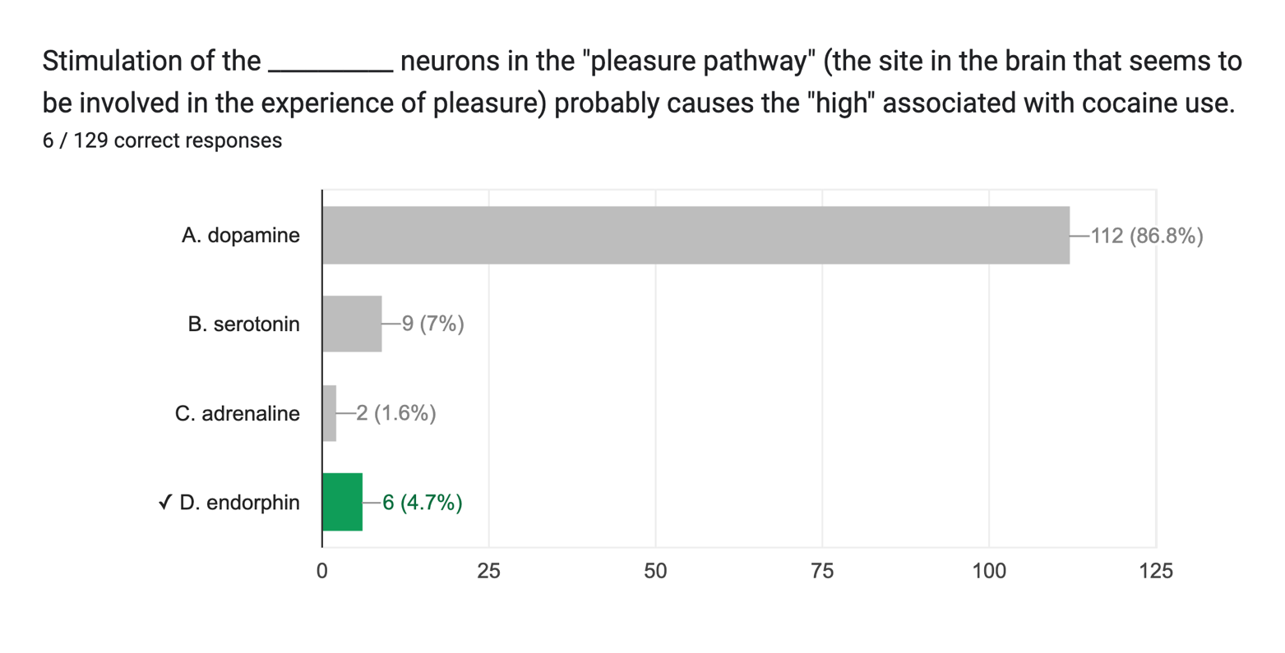

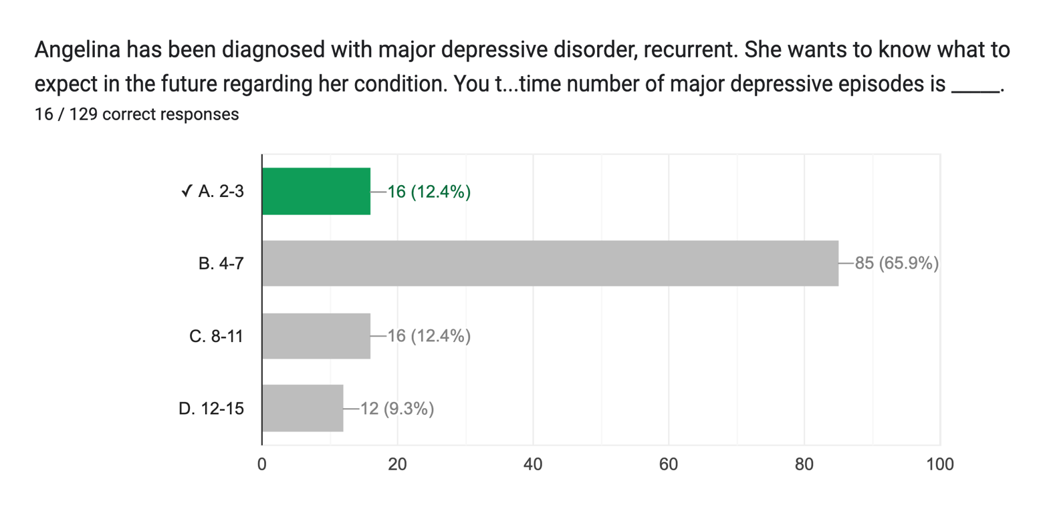

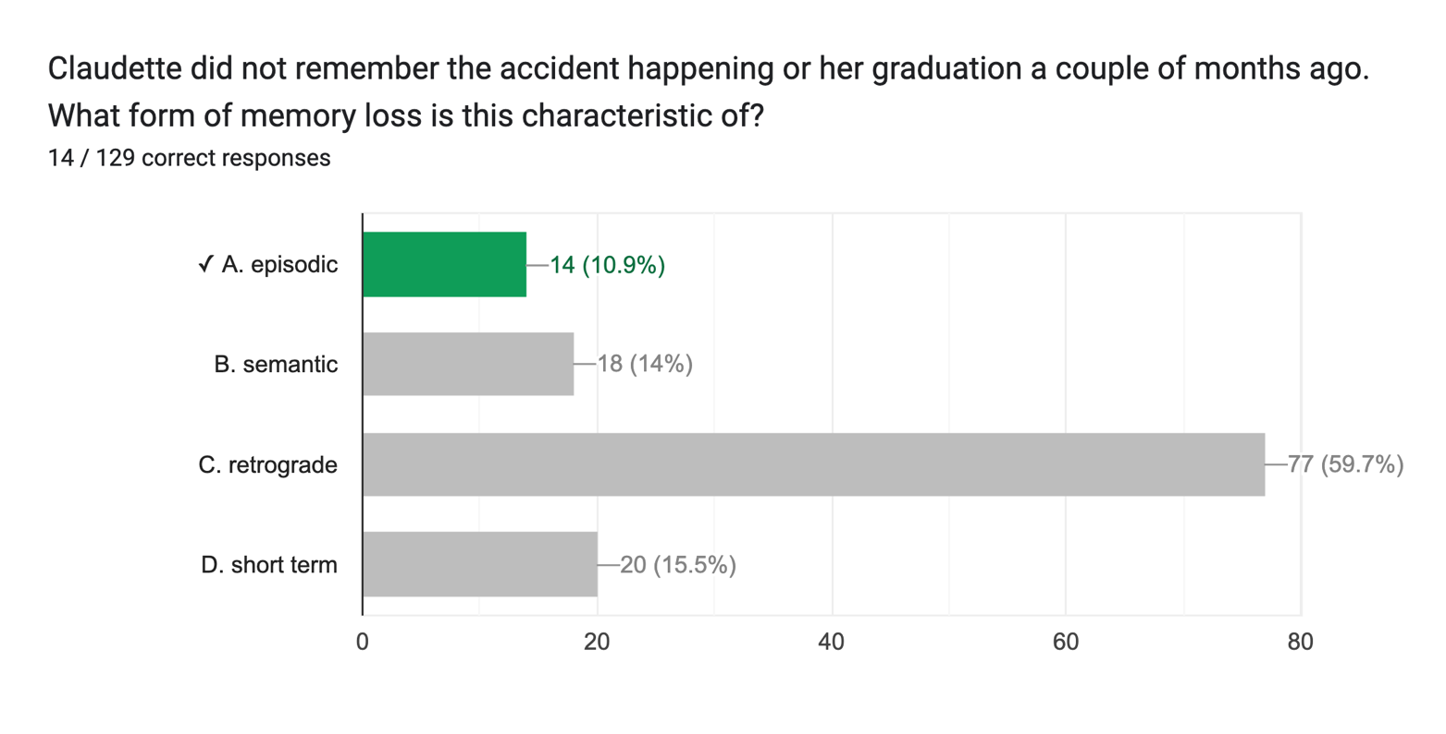

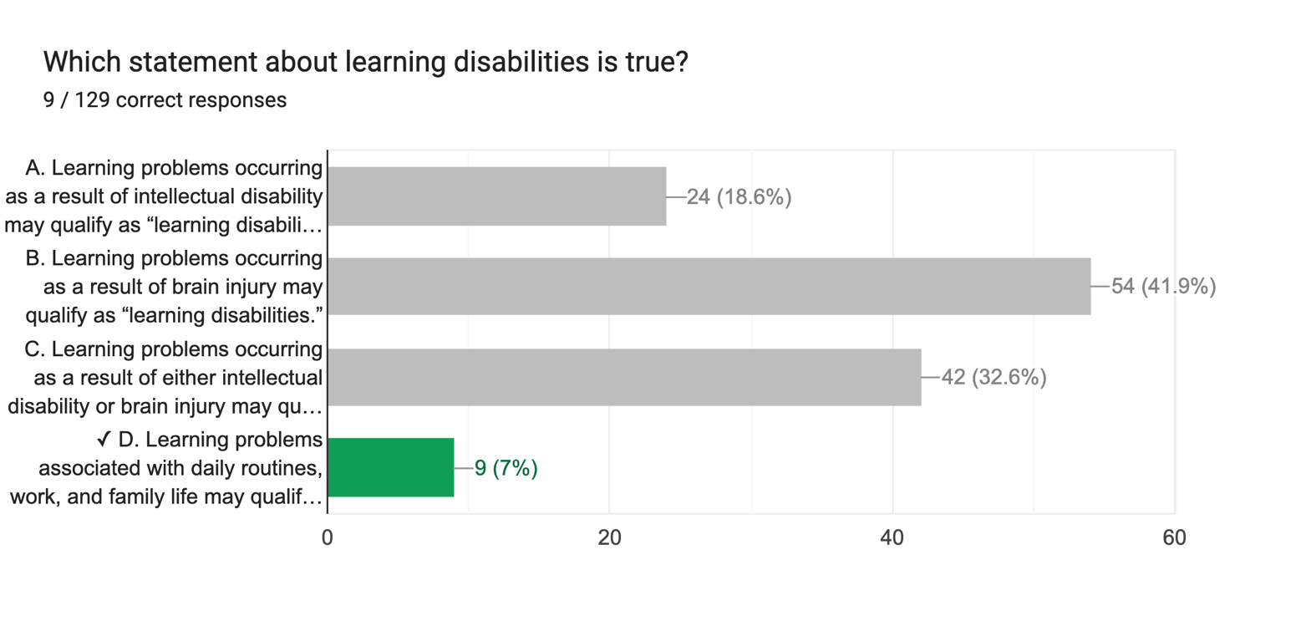

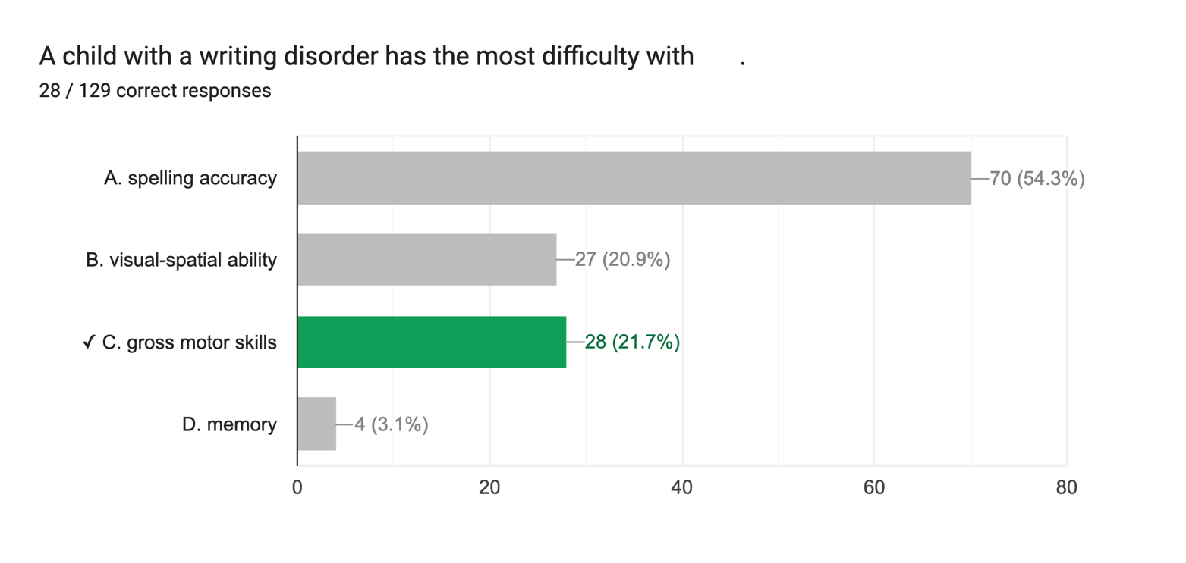

ANALYSIS ON THE RESULT OF PRE-BOARD EXAMINATION IN INDUSTRIAL PSYCHOLOGY
MARCH 8, 2025

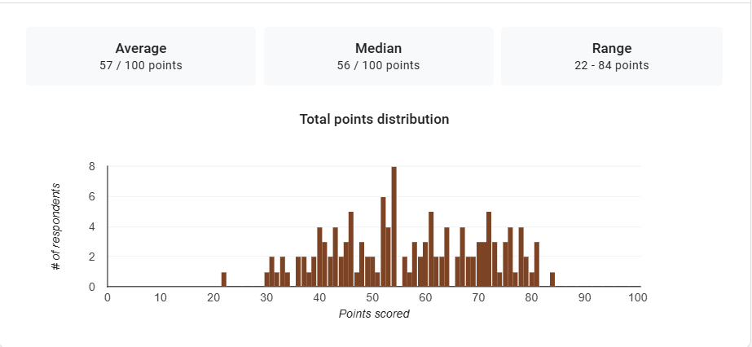

1. Mean Score: The mean (average) score of the exam is 57 out of 100, which indicates that, on the whole, students are scoring just over half of the total possible points suggesting that most students may be performing at a moderate level. It implies that the exam was somewhat challenging for the group as a whole, as the average score is not particularly high.

2. Median Score: The median score is 56 out of 100. Since the median score is slightly lower than the mean, this might indicate that the distribution of scores could be slightly skewed to the right (positively skewed), where a small number of students performed better, pulling the average score up.
3. Range: The range of scores is from 22 to 84 points. This indicates a significant spread between the lowest and highest scores, with students' performance varying considerably. The fact that the lowest score is 22 and the highest is 84 suggests that some students performed quite poorly, while others performed much better.
Interpretation Summary:

-The exam results show a moderate average performance, with most students scoring around the middle (56–57).

-The wide range of scores indicates disparities in student performance. Some students are struggling, as seen by the low scores, while others are excelling.

-The variability could reflect differences in preparation, understanding, or test-taking abilities; suggesting the need for targeted support for lower-performing students and potentially further analysis to understand the factors contributing to the disparity in performance.

RATIONALIZATION:

DIFFICULT QUESTIONS:
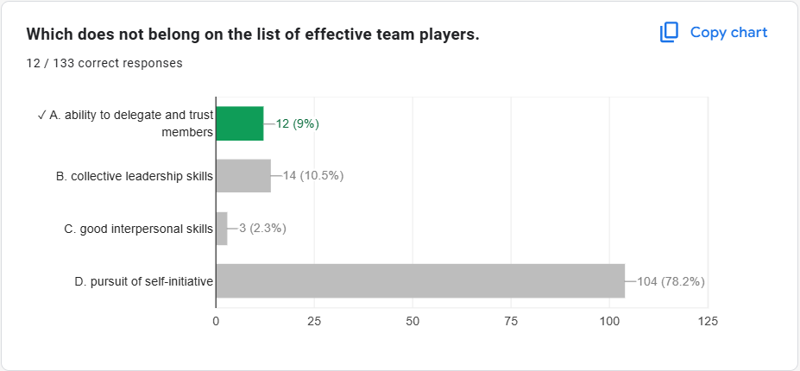
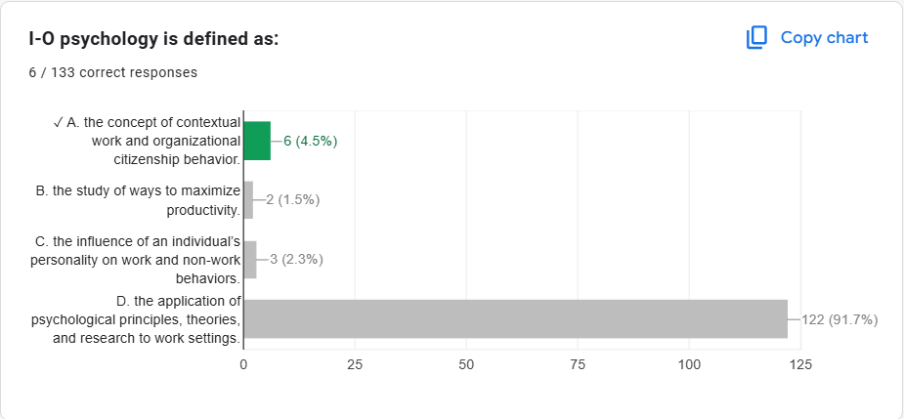
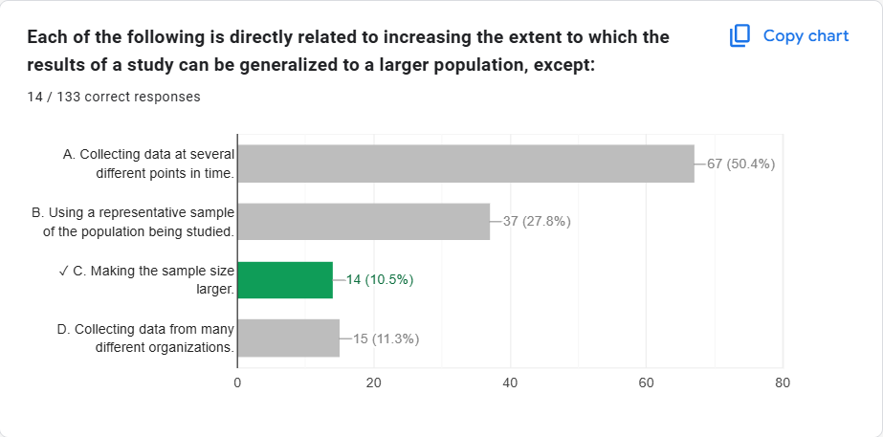

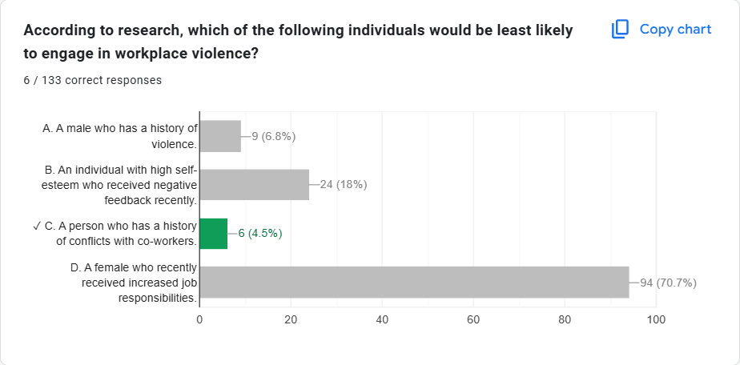

ANALYSIS ON THE RESULT OF PRE-BOARD EXAMINATION IN DEVELOPMENTAL PSYCHOLOGY
MARCH 8, 2025
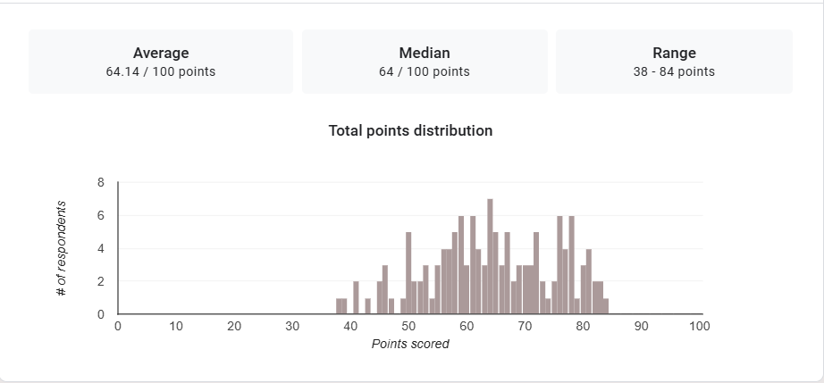

1. Mean Score: The mean (average) score of the exam is 64.14 out of 100 suggests that, on average, students performed slightly above the middle range (50%) but didn't score exceptionally well. This implies that most students are performing at an intermediate level, with a few performing better and others possibly struggling.

2. Median Score: The median score is 64 out of 100. The fact that both the median and the mean are around 64 indicates that the general performance of the group is in the middle range, with a typical spread of scores around the 60-70 mark.
3. Range: The range of scores is from 38 to 84 points indicates that the lowest score achieved was 38, and the highest score was 84. This shows that there is a considerable spread between the highest and lowest scores, with a difference of 46 points.
Interpretation Summary:

-The average score isn't too low, it suggests that overall performance could be better, and there might be areas that need more attention or improvement for the group of students.

-Since the median is 64, this indicates that 50% of students scored below 64, and 50% scored above it, suggesting that the overall performance of the group is moderate, with a balance between students scoring below and above this value, and there may still be areas where further improvement could be made.

- The relatively low minimum score (38) and the relatively high maximum score (84) shows a wide range which implies the presence of outliers. This suggests that while some students performed well, others may have significant gaps in their knowledge or preparation.
RATIONALIZATION:

DIFFICULT QUESTIONS:

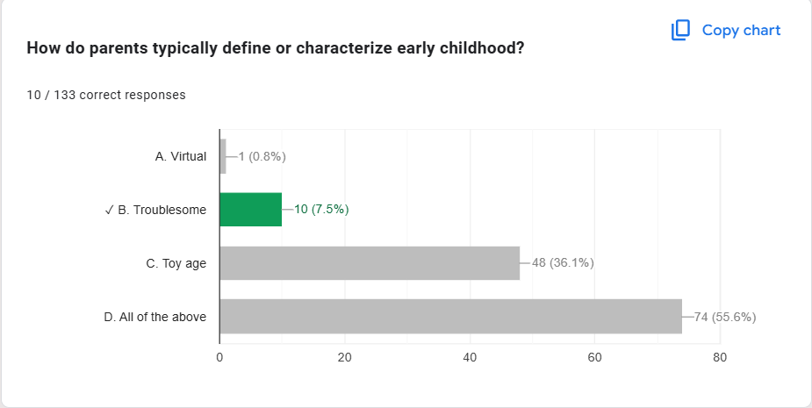
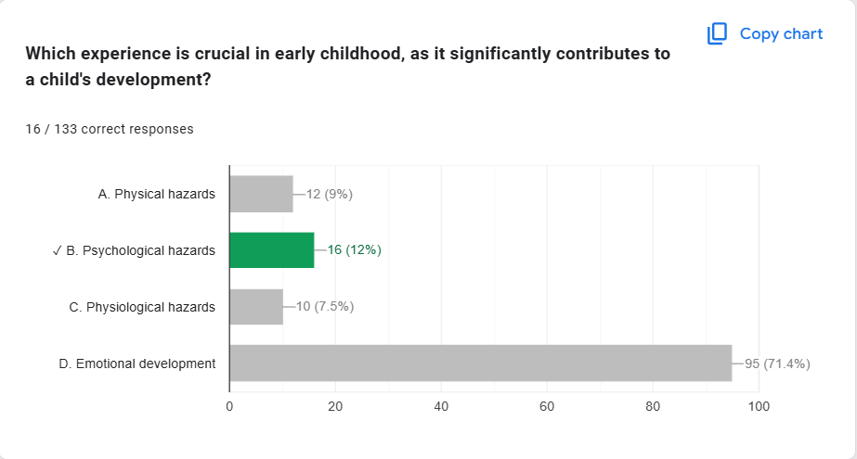

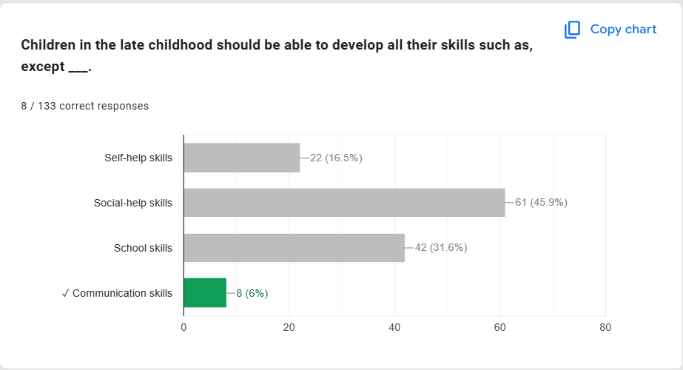

ANALYSIS ON THE RESULT OF PRE-BOARD EXAMINATION IN PSYCHOLOGICAL ASSESSMENT
MARCH 8, 2025
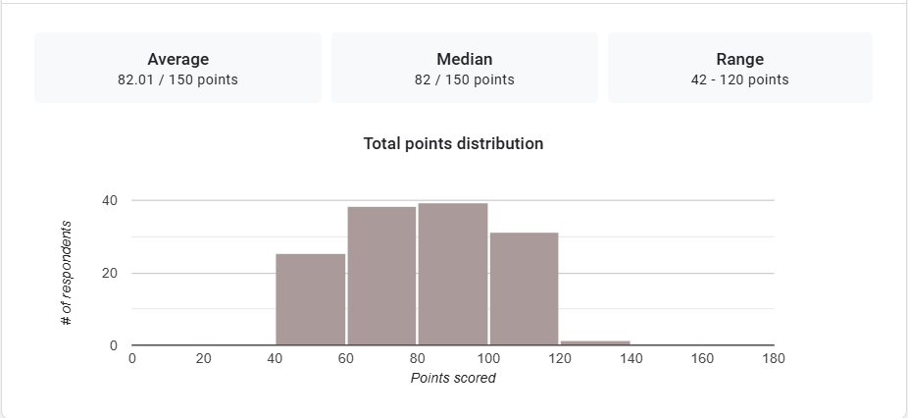
1. Mean Score: The mean (average) score of the exam is 82.01 out of 150 suggest that, on average, students performed moderately on the exam. Since 82.01 is just over half of the maximum possible score (150), it indicates that the majority of students scored somewhat below the maximum, but not necessarily poorly.

2. Median Score: The median score is 82 out of 150. This suggests that the distribution of scores is fairly balanced around this value. The fact that the median and mean are nearly identical implies that there aren’t extreme outliers (very high or very low scores) pulling the average in one direction.
3. Range: The range of scores is from 42 to 120, indicating that there is a fairly wide spread of scores. The scores vary by 78 points, showing that some students performed significantly better than others, and the lowest score was much lower than the highest.
Interpretation Summary:

-Given that the average score is just a little over half of the total possible points, it suggests that there may be areas in the exam where students struggled or didn't perform as well as expected.

-Since the median is just above half of the total possible score (150), it suggests that the middle-performing students achieved a moderate score. Most students are likely clustered around this median, implying that the exam might have been appropriately challenging for the group overall, with a significant number of students performing around this level.

-The range shows that some students struggled quite a bit (with a score as low as 42), while others performed fairly well (with a score as high as 120). The exam may have been challenging enough to create these extremes in performance, or there may have been differences in preparation or understanding among the students.
RATIONALIZATION:

DIFFICULT QUESTIONS:

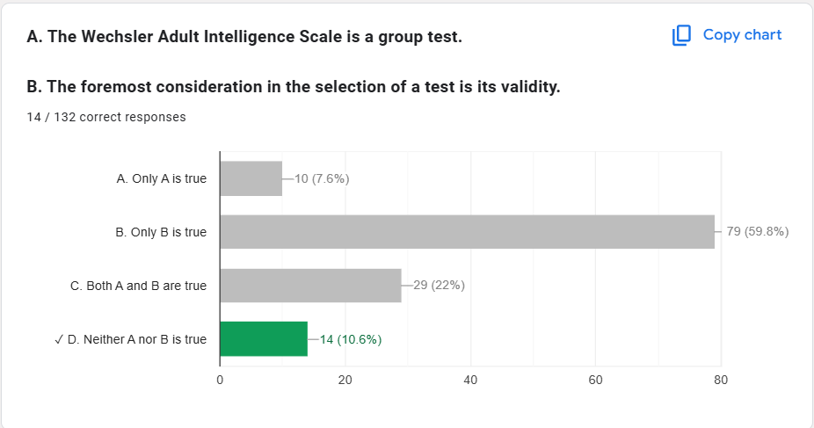

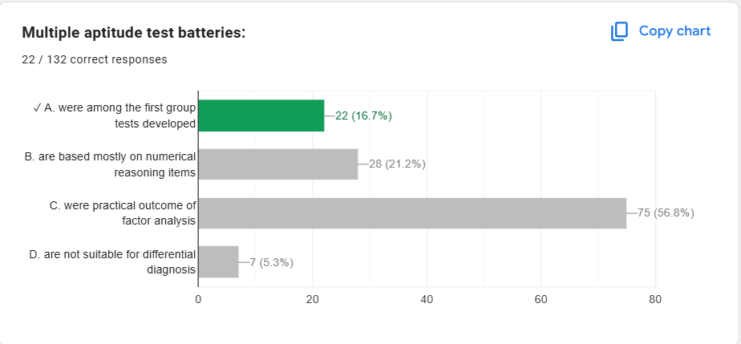

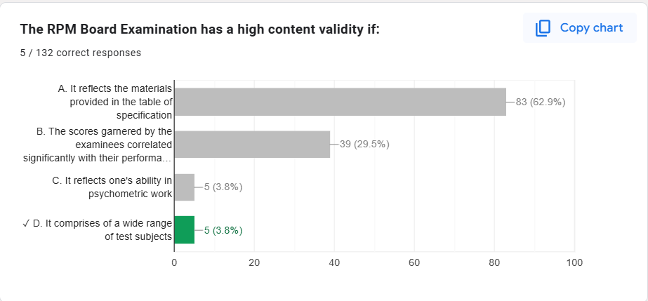

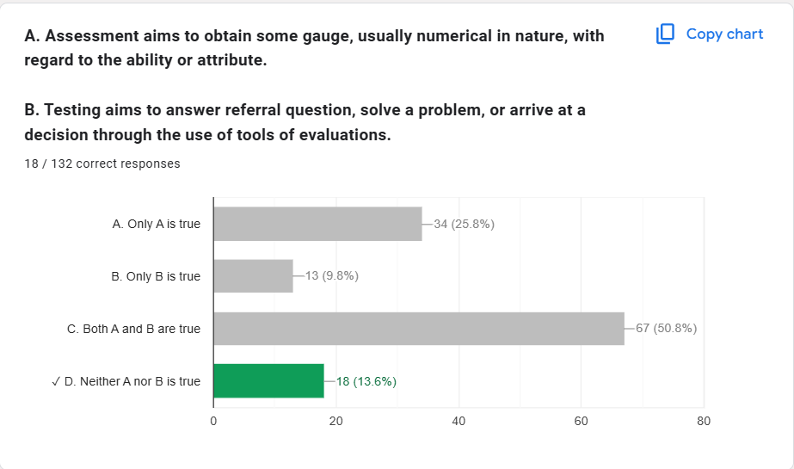

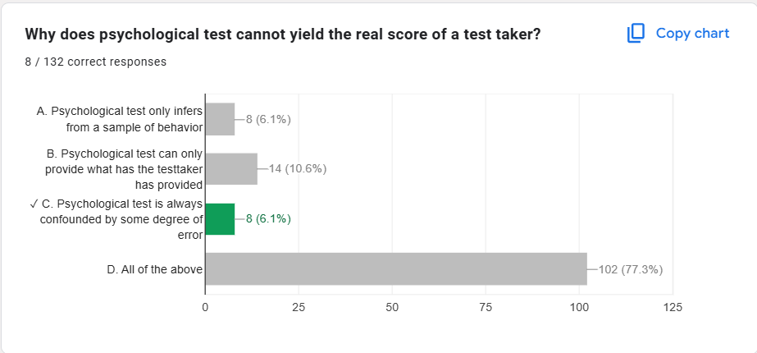

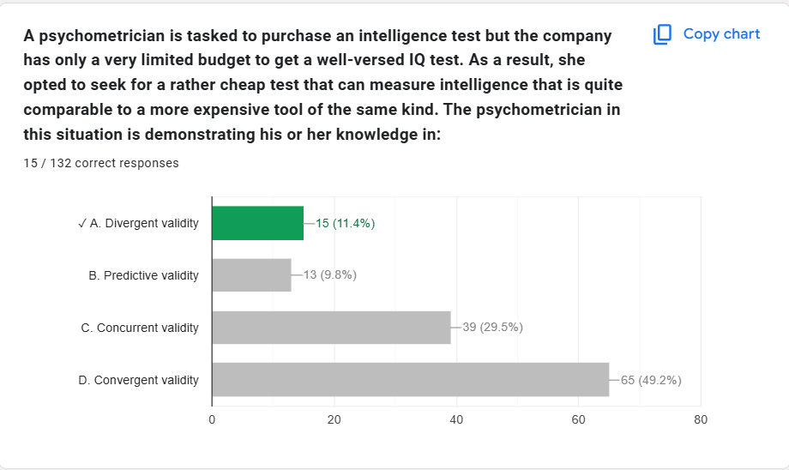

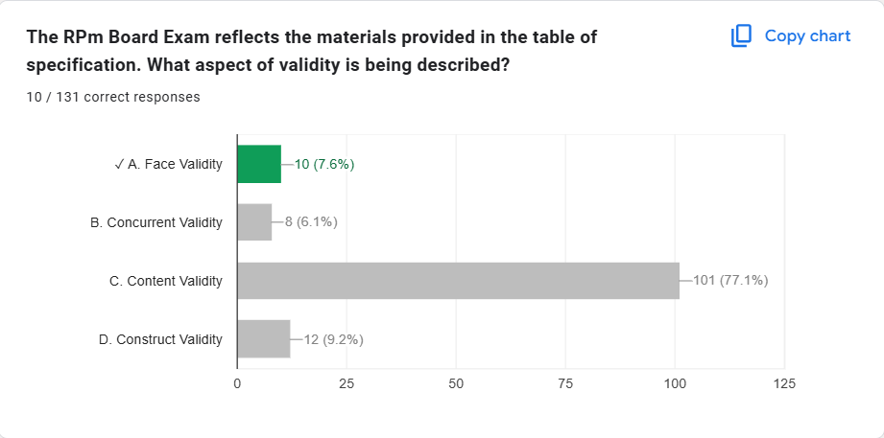

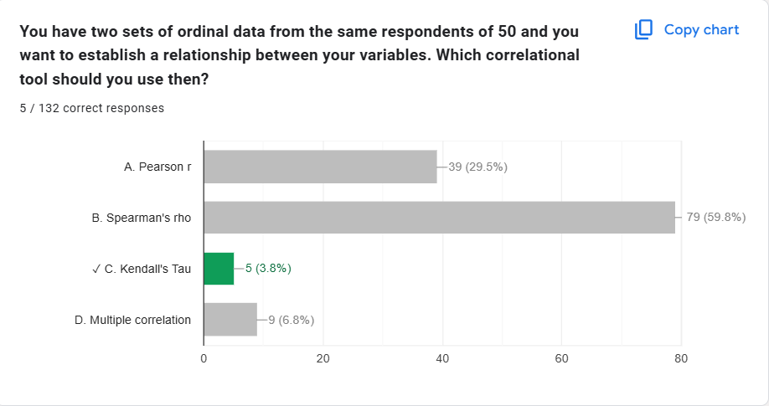

Based on the observations you've provided regarding the students' exam performance, several targeted interventions can be implemented to address the variability in understanding and to support both struggling and high-achieving students. Here are some suggestions:

1. **Differentiated Instruction:**
- Tailor instructional strategies to accommodate varying skill levels. This might include providing advanced materials or projects for high-achieving students while offering more foundational support or alternative resources for those who struggled.

2. **Targeted Review Sessions:**
- Organize optional review sessions or study workshops focused on challenging topics. These could be led by teachers or peer tutors and specifically designed to address areas where students performed poorly.

3. **Study Skills Workshops:**
- Offer workshops that teach effective study strategies, time management, and test-taking techniques. This can help students develop better preparation habits for future assessments.

4. **Formative Assessments:**
- Implement periodic low-stakes assessments (quizzes, reflections) to gauge students' understanding throughout the course. This can help identify students who are struggling sooner, allowing for timely intervention.

5. **Peer Tutoring Programs:**
- Establish a peer tutoring system where students who excel in certain areas can support those who are struggling. This encourages collaborative learning and can boost confidence among both groups.

6. **Individualized Learning Plans:**
- Create personalized learning plans for students who demonstrate significant gaps in understanding. This may involve setting specific goals, choosing appropriate resources, and scheduling regular check-ins.

7. **Feedback Mechanisms:**
- Provide constructive feedback on the exam results, highlighting strengths and areas for improvement. Encourage students to reflect on their performance and set improvement goals.

8. **Resource Availability:**
- Ensure that students have access to additional resources, such as textbooks, online materials, or supplementary readings, to strengthen their understanding of the subject matter.

9. **Parent/Guardian Engagement:**
- Communicate with parents or guardians about students' performance, including ways they can support their children at home with study habits or motivational support.

10. **Mental Health and Wellbeing Support:**
- Address any potential psychological barriers, such as anxiety or lack of motivation, by providing access to counseling services or developing a positive classroom environment that emphasizes growth and learning.

Implementing a combination of these interventions can help create a more inclusive and supportive learning environment, ultimately improving student performance and confidence in their academic abilities.

